**Dataset:**

<https://docs.google.com/spreadsheets/d/1IRSEnmgz8Ro276->

[GslknRNk0zlrB5CZH1YrnT71kqFM/edit?usp=sharing](https://docs.google.com/spreadsheets/d/1IRSEnmgz8Ro276-)

**Use the above dataset and answer the following questions**.

1. **Create a Pivot table and show what the main export product is?**

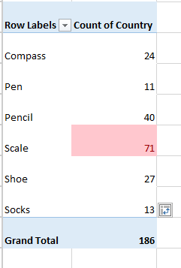

1. **Create a bar graph showing the amount spent for each product?**

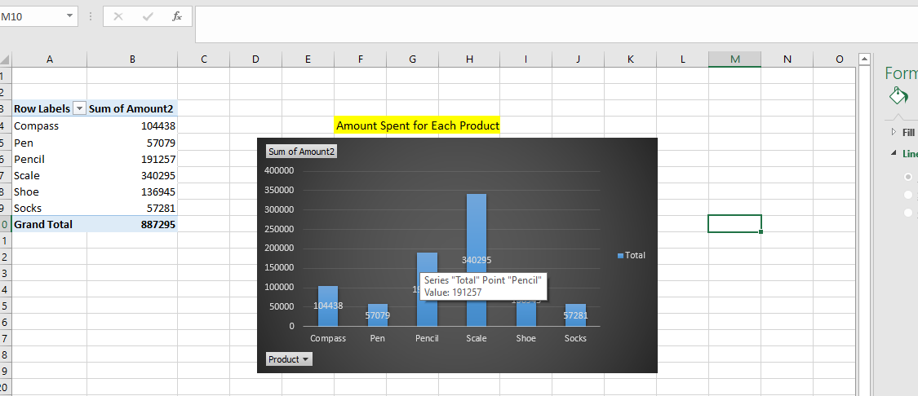

**3. Create a Pivot table to show The sales in each city**

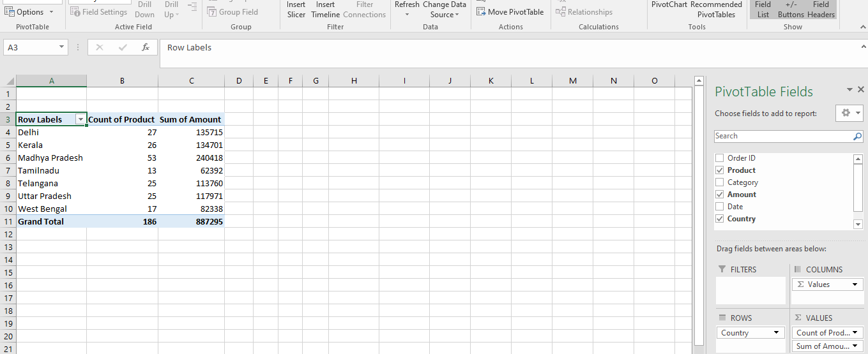

1. **Create a chart showing the amount spent for each product in each city.**

